1. What Javascript feature is used to initiate the given request?

jQuery

1. What two things needed to be added to the Startup.cs file to allow Javascript processing?

App.UseDefaultFiles();

App.UseStaticFiles();

1. What file was added to the project that contains the code for the Javascript functions?

Site.js

1. List the name of each Javascript function and the corresponding HTTP type that the function is performing.

getData: GET  
addItem: PUT

deleteItem: DELETE

editItem: PATCH

1. What is the accepts option set to in order to specify that the data should be exchanged in JSON format?

“application/json”

1. What JSON command is used to convert the data returned to a JSON string?

JSON.stringify

1. Run the app using the new index.html page with Javascript processing. Do screen prints showing an add of a new item, a change to that item, then a delete of that item.

My app with new JavaScript

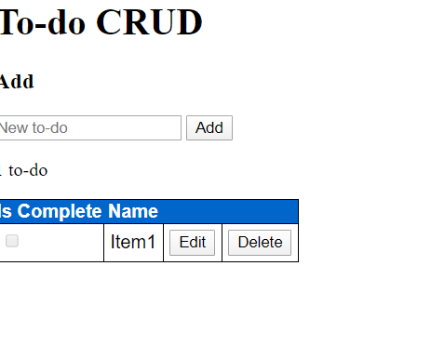

Me adding a new To-do Item

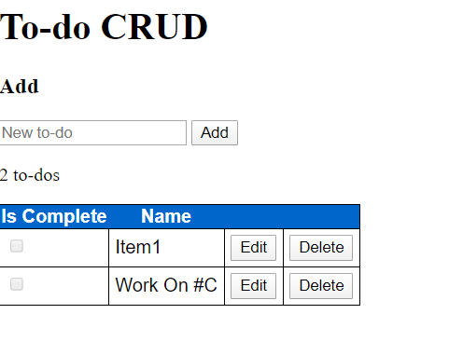

Me changing the “Work On C#” Item to “Is Complete”

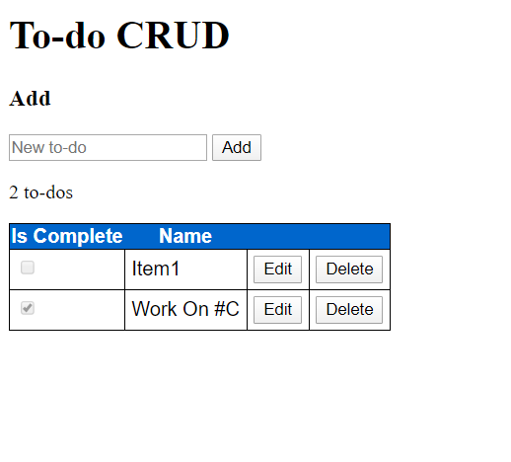

The new field being deleted

